**Premier League 2024/2025: A Season Told Through Data**

**Introduction**

Football isn’t just about goals and whistles, it’s about moments, momentum, and magic. The 2024/2025 Premier League season had all of that, and through this report, we dive into what the numbers tell us about the journey. We look beyond the scorelines to understand what truly drove team performances: from packed stadiums and superstar players to tactics that defied expectations.

**The Story Behind the Data**

This project focused on the English Premier League and brought together a range of stats: matches played, goals scored, clean sheets, attendance figures, expected goals (xG), and more. We wanted to understand the “why” behind the “what.”

1. Liverpool topped the table with 84 points, thanks in no small part to Mohamed Salah’s 29 goals and Alisson’s 9 clean sheets.
2. David Raya stood out for Arsenal, keeping 13 clean sheets, the most in the league.
3. One of the biggest surprises? Nottingham Forest, who beat expectations by a huge margin in goal difference (+15.40).
4. On the flip side, Southampton struggled big time with a -60 goal difference and just 12 points.

This data wasn’t just numbers, it painted a real picture of effort, challenges, and unexpected outcomes across the league.

**What We Looked At (Pre-Analysis)**

Before jumping into the analysis, we asked: what matters most in football performance? We grouped the data into two types:

1. Independent values like matches played, wins, attendance, or clean sheets, things that directly impact outcomes.
2. Dependent values like total points, league rankings, and goal differences, results that come *from* those efforts.

We also thought about who this analysis matters to clubs, coaches, players, sports analysts, fans, media, and even betting companies.

Success here isn’t just about lifting a trophy, it’s about:

1. Predicting performance better.
2. Improving tactics.
3. Keeping fans engaged.
4. Supporting smarter, data-driven decisions.

**Mid-Season Discoveries (In-Analysis)**

As the season unfolded, patterns started to emerge:

1. Liverpool’s winning formula was clear: a reliable goal machine (Salah) and a solid wall at the back (Alisson).
2. Nottingham Forest really stood out, their stats showed they were outperforming their expected results by over 15 goals! That’s not luck, that’s smart football.
3. Southampton, unfortunately, had a season to forget. The gap in their defense and lack of goals saw them slide to the bottom. This got them relegated to the championship
4. The roar of the crowd made a difference too. Manchester United had the biggest home attendance (73,747), and that energy seemed to give them an edge.
5. Teams with top-performing goalkeepers like Arsenal showed more consistency in their points per match.

**What We Learned (Post-Analysis & Insights)**

* Teams that overachieved compared to expected goals (like Nottingham Forest) deserve a closer look. Their tactics are working and might be worth replicating.
* There's a real link between **big crowds** and better results. Fan energy matters.
* Clean sheets = confidence = points. A reliable goalkeeper can be the quiet MVP of any squad.
* Struggling teams need to fix both ends of the pitch not just score more but stop leaking goals.

**What Needs to Happen Next (Recommendations)**

1. For teams like Southampton: Get stronger in key areas. Sign experienced defenders and clinical strikers. Invest in goalkeeping. Tighten up tactics.
2. For teams like Nottingham Forest: Stick with what's working. Analyze what’s making them beat the odds, and double down on it.

**Visualization**

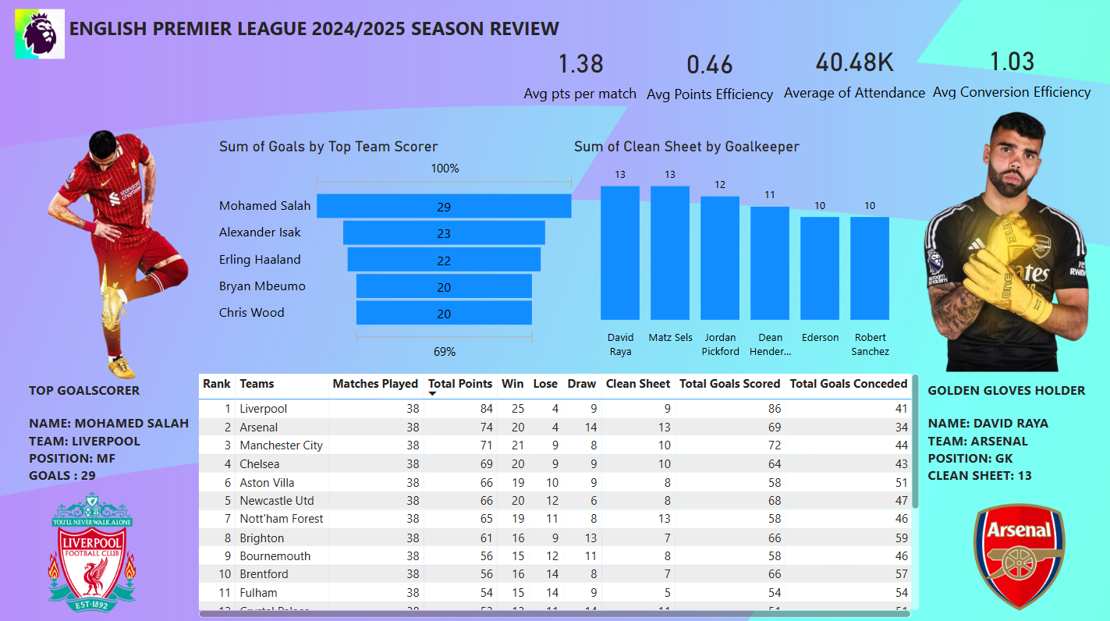

**English Premier League 2024/2025 season Review**

**Conclusion**

The 2024/2025 Premier League season showed how much balance matters in football. Liverpool got it right with firepower and stability. Nottingham Forest proved that smart tactics can beat the odds. And teams like Southampton remind us how tough the league can be if you fall behind.

This analysis gives clubs, fans, and decision-makers a clearer view of what’s happening on the pitch and how to turn numbers into better results next season.